**PYTHON ASSESSMENT**

**Coding Assesment:**

**1.Explain Python Module with examples  
a.Import module in Python  
.Renaming the Python module**

A [python](https://www.geeksforgeeks.org/python-programming-language/)module is a file containing Python definitions and statements. A module can define functions, classes, and variables.

1. **Import module in Python**

## We can import the functions, and classes defined in a module to another module using the **import statement** in some other Python source file.

## Syntax to import module

## Import module

## ****Importing modules in Python Example****

## 

## Renaming the python module

We can rename the module while importing it using the keyword.

**Syntax:** Import Module_name as Alias_name

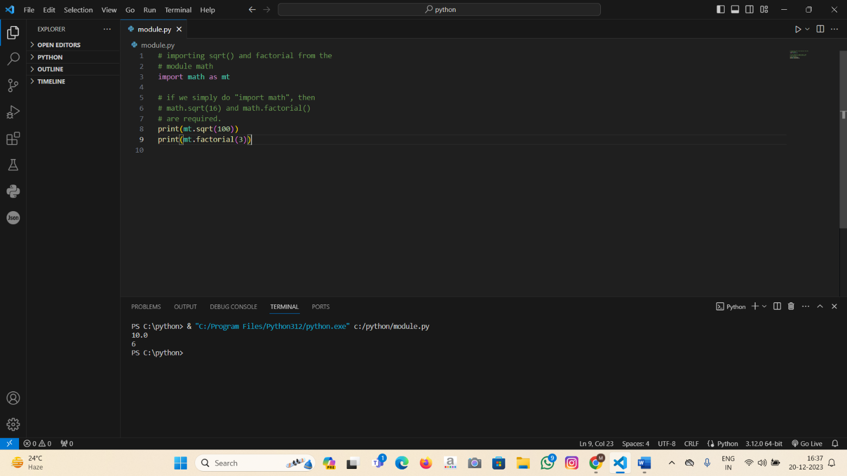

**2. Explain Pandas and Numpy using Examples In python**

**Pandas:**

Pandas is a Python library used for working with data sets.

It has functions for analyzing, cleaning, exploring, and manipulating data.

Pandas allows us to analyze big data and make conclusions.

**Example Of Pandas:**

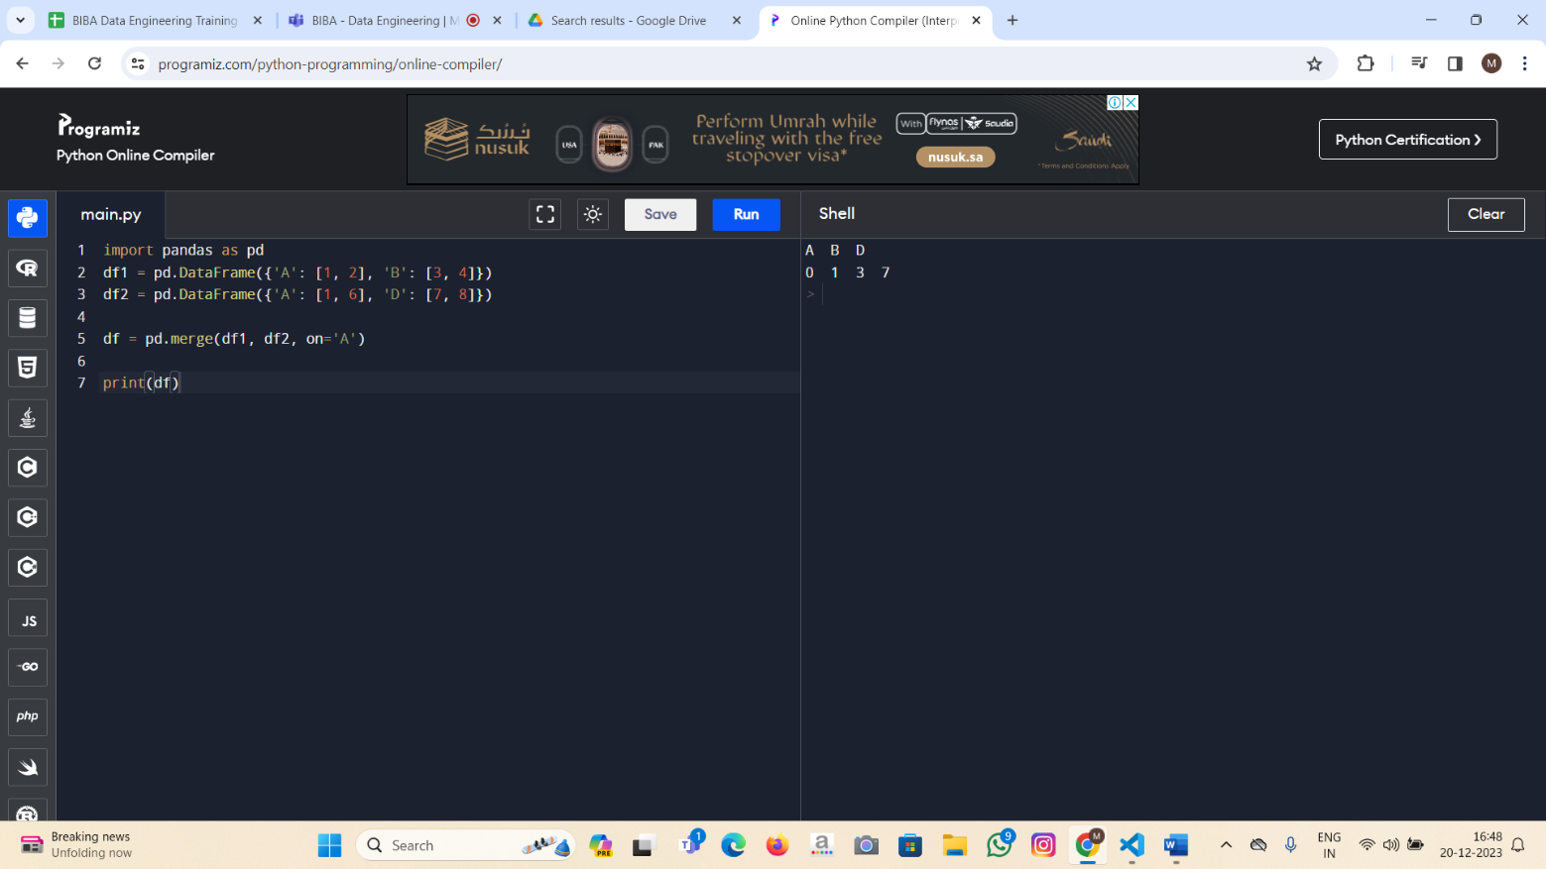

**NUMPY:**

NumPy is a Python library used for working with arrays.

NumPy Stands for Numerical Python.

It uses negative indexing to access an array from the end.

**Example Of Numpy:**

